# Service Name: Final Fire NOC

# Process Flow / Procedure

* Architect/ Builder can apply for the service on Web, Aaple Sarkar, and Mobile App or can visit to CFC/ULB office. On Web, he can upload the supporting mandatory documents.
* Pay the prescribed fees (if applicable) either Online (Credit Card/Debit Card/Net Banking) or Offline (At ULB/CFC).
* Application no. is generated which is further can be used by applicant to track the application.
* Applicant will be informed through SMS and email for every important event.
* Verification of documents will be done at ULB/CFC counter. Citizen needs to submit the copies of the documents at the ULB/CFC counter. ULB/CFC clerk will check all the documents and authorize or Un-authorize the application.
* If application is un-authorized then citizen can re-submit document or can correct the application form.
* If application is authorized then it will be scrutinized (if applicable) by the respective department.
* If application is rejected during final scrutiny then rejection letter will be generated and intimated to applicant through SMS and email.
* Once the application is scrutinized (if applicable), LOI charges will be auto populated based on charge master setup and generate the LOI (if applicable).
* Applicant needs to make the payment against the LOI (if applicable).
* Later, Citizen will avail the digitally signed certificate against the service applied through online login or from the ULB/CFC counter.

|  |  |
| --- | --- |
| Services | No. of days |
| Application for Final Fire NOC |  |

* Timeline to complete the Services
* Scrutiny Levels

|  |  |  |
| --- | --- | --- |
| Services | No. of Scrutiny Levels | |
| **Council** | **Corporation** |
| Application for Final Fire NOC | 2 | 3 |

## **Service Wise Workflow**

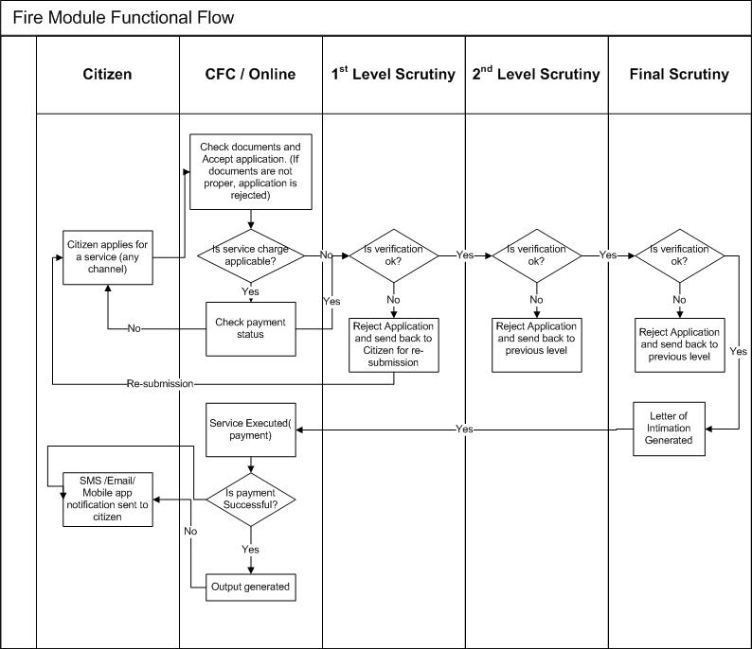

## **Document Checklist**

|  |  |  |
| --- | --- | --- |
| Services | Required documents from Citizen | Documents verified by ULB |
| Application for Final Fire NOC | * D.G. Set certificate | * Provisional Fire NOC No. |
| * 100 Rs. Stamp Paper Agreement | * Building permission Certificate |
| * Agency Certificate | * Copy of Initials/Amended NOC issued by Fire Brigade Dept. |
|  | * 3 sets of Architectural Plan |
|  | * Lift Certificate |
|  | * Provisional Fire NOC No. |

## **Screenshots**

* Step 1: User should enter the application details, attach mandatory documents and click on “Pay” button.

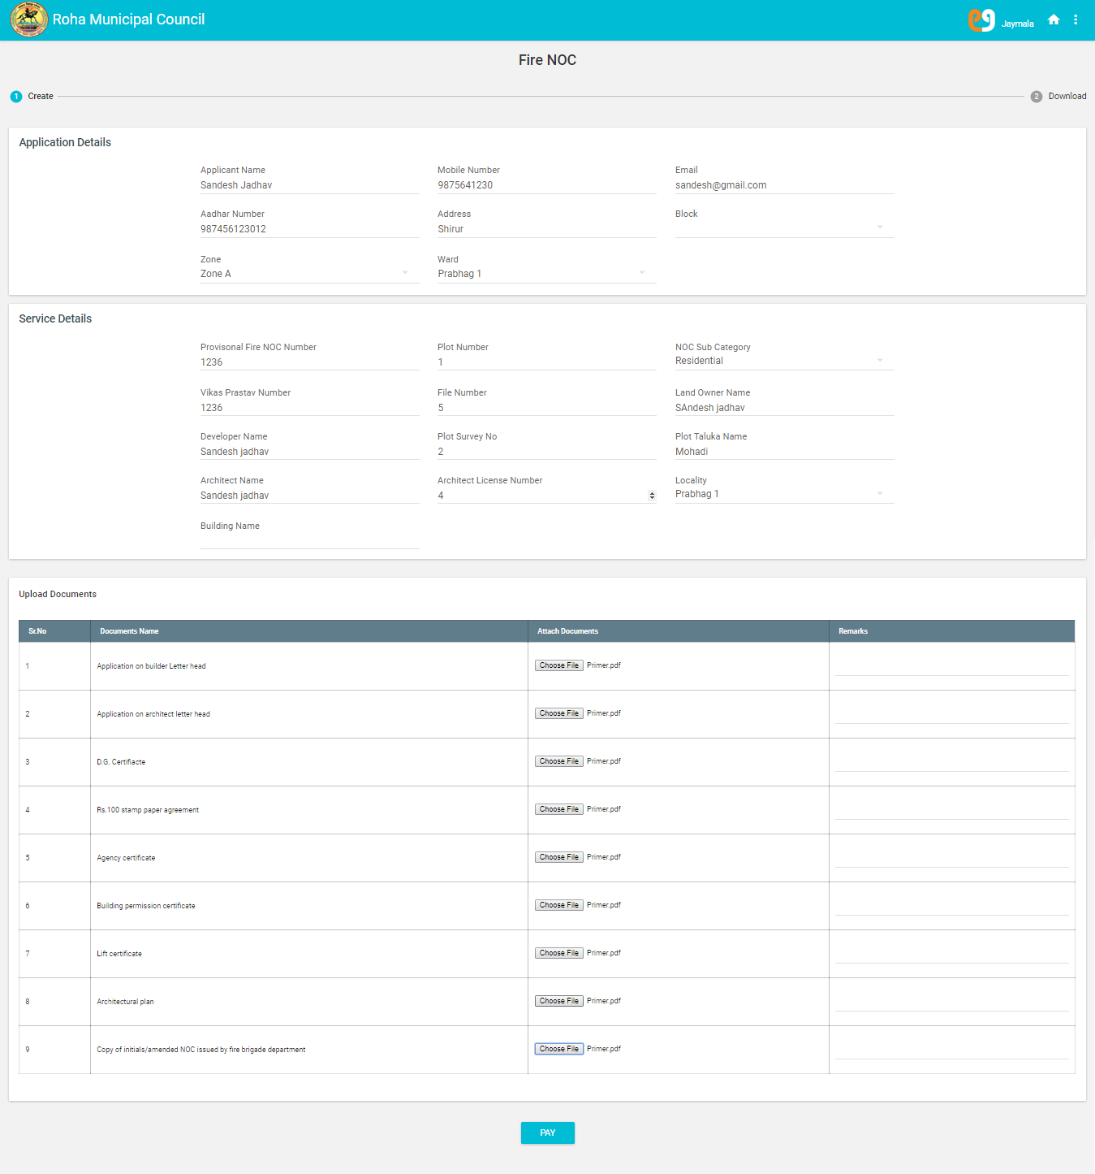

* Step 2: User should click on “Pay” button to proceed with payment. After Clicking on Pay Button, page will be redirect to the Mahaonline Payment Mode Page

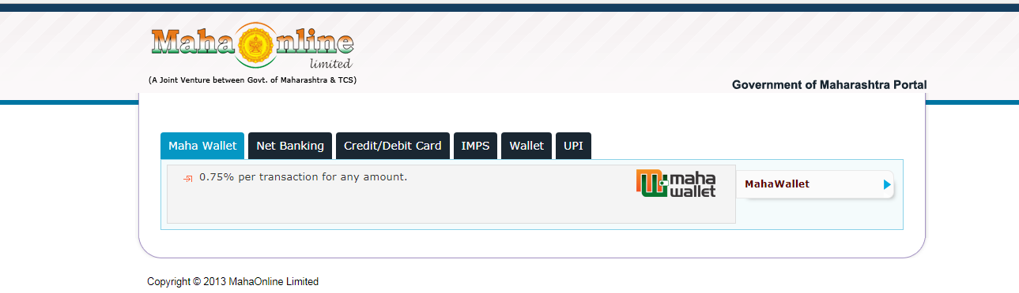

* Step 3: After Clicking on Net banking Option on the Mahaonline Payment Mode Page it will redirect to the Net Banking Option Page

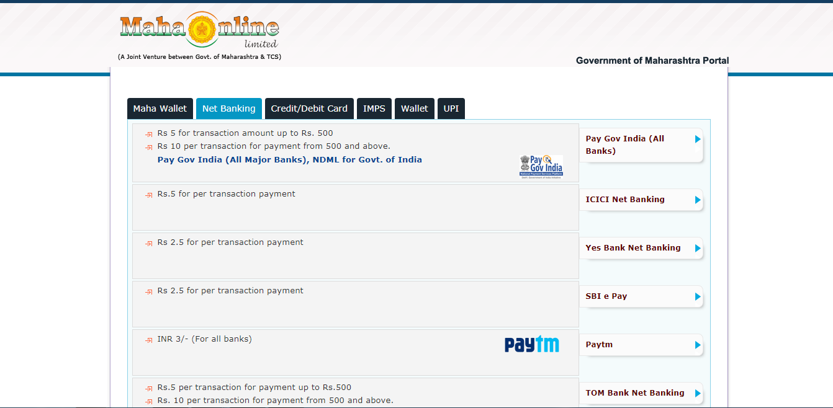

* Step 4: After Clicking on Yes Bank Net banking Option on the Mahaonline Payment Mode Page it will redirect to the Payment Details Page.

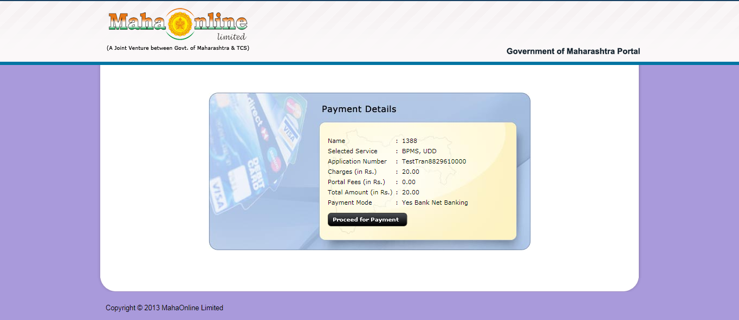

* Step 5: After Clicking “Proceed for Payment” button on the Mahaonline Payment Mode Page it will redirect to the Atom Payment Option Page.

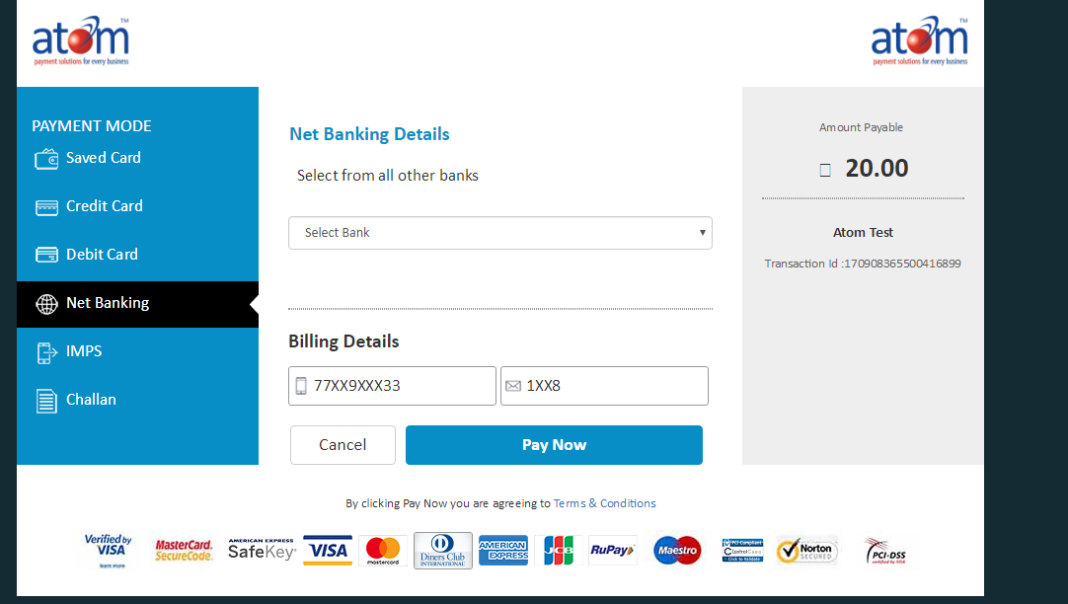

* Step 6: After selecting Net banking Option and selecting Bank As Atom bank clicking on Pay Now button it will redirect to the Atom Transaction Page.

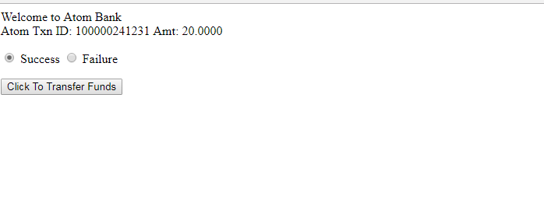

* Step 7: After Clicking On Click To Transfer Funds button it display the below message

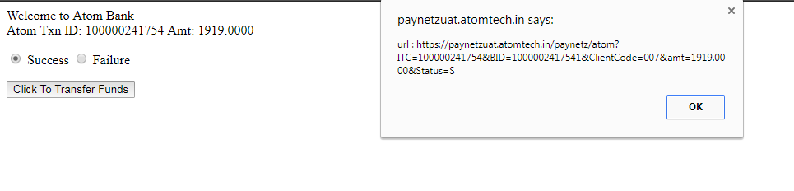

* Step 9: After clicking on Ok Button of the message displayed on the above screen it generates No Due Certificate for Property Tax

